**Image Critique Assessment – Month 4**

In the *‘Obstetric and gynaecologic ultrasound curriculum and competency assessment in residency training programs: consensus report’* (attached on the Phase II webpage) the following image criteria are listed as additional competencies:

1. Three vessels and trachea view
2. Face: orbits
3. Umbilical artery Doppler
4. Nuchal translucency
5. Saline contrast sonohysterography

*The following assessment provides images from this level of competency for you to assess. Please provide feedback for each image in the box provide underneath the image. This feedback will be assessed by your virtual mentor who will support you in improving your image critiquing.*

**Orbits**

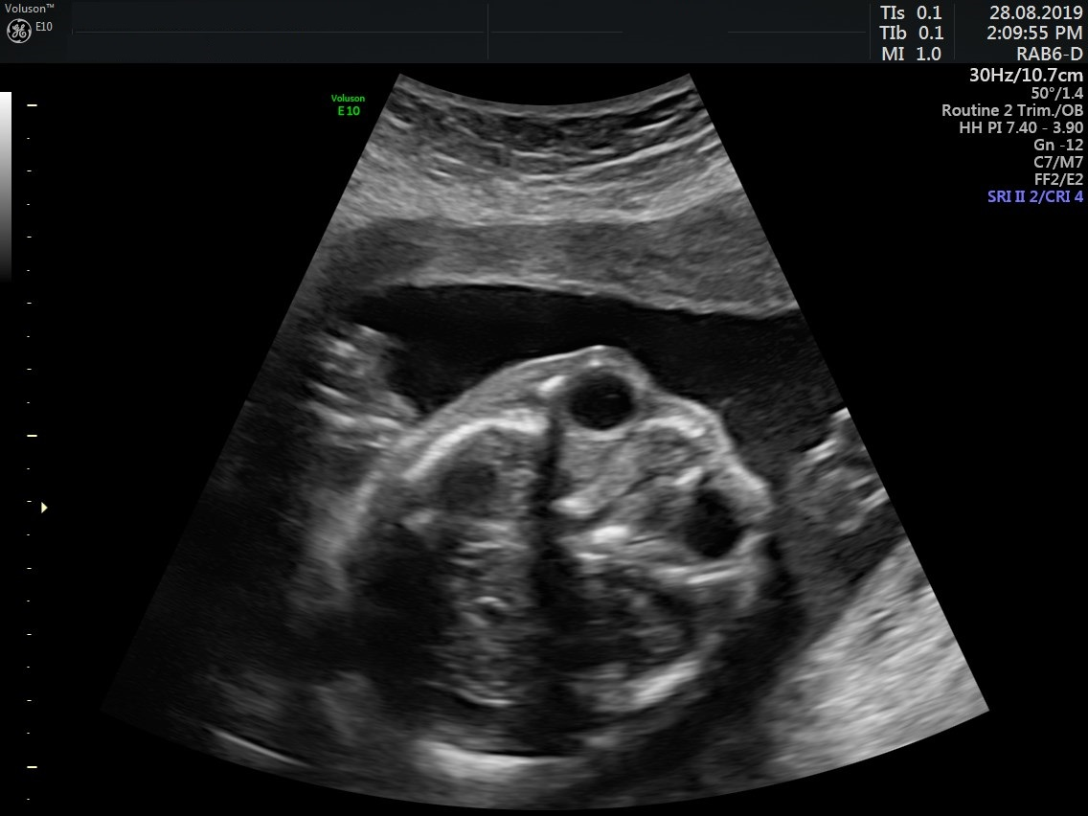

*[Provide feedback for the image here]*

**Umbilical Artery Doppler**

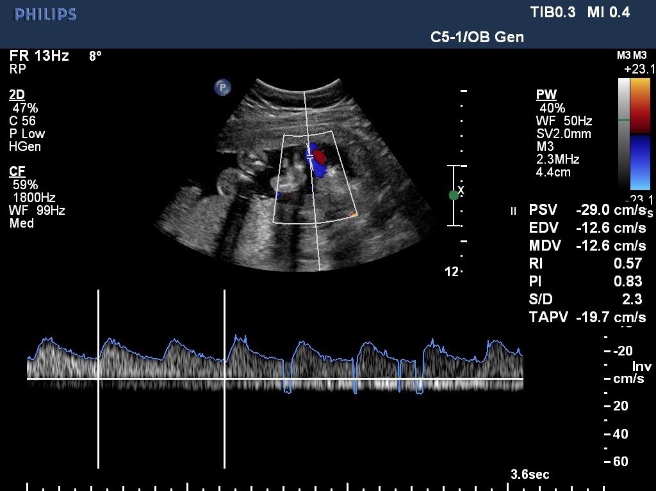

*[Provide feedback for the image here]*

**Three vessel trachea view**

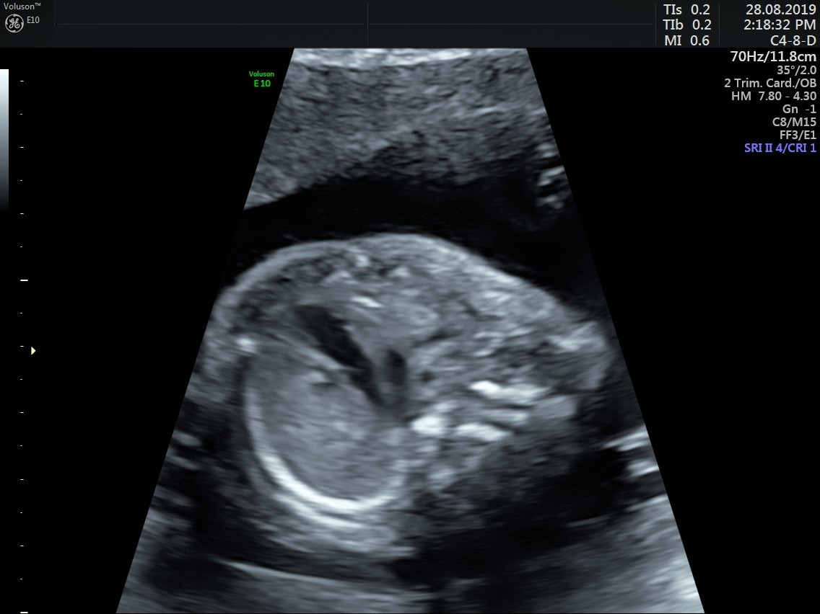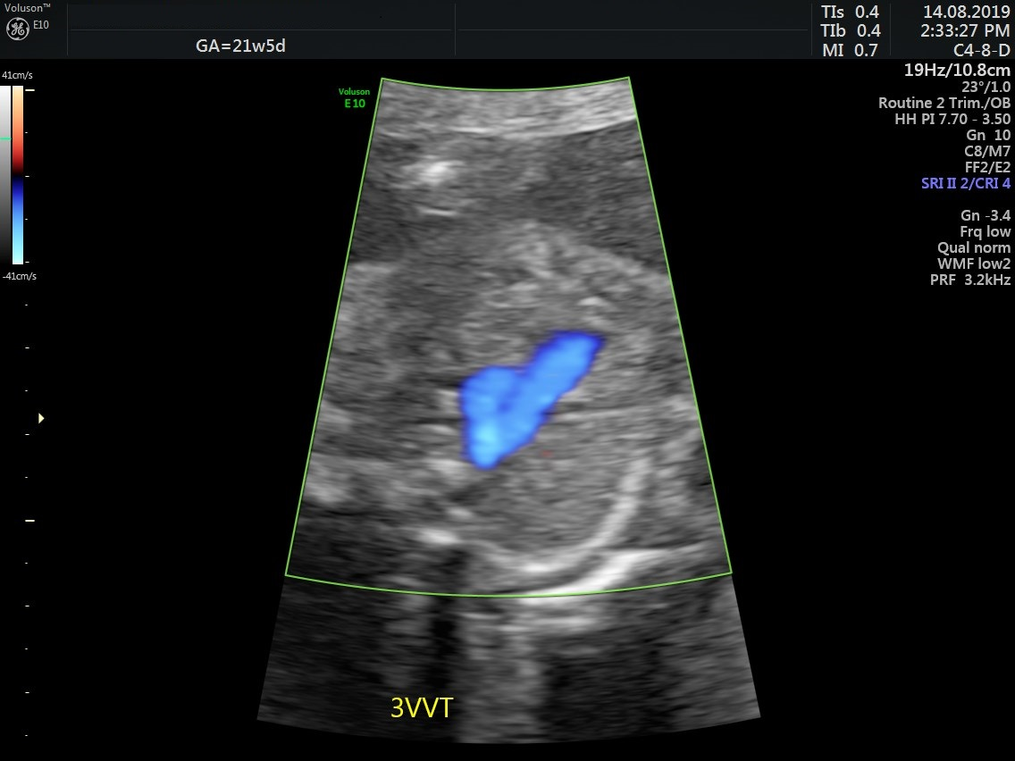

*[Provide feedback for the image here]*