Image Critique Assessment – Month 6
In the ‘Obstetric and gynaecologic ultrasound curriculum and competency assessment in residency training programs: consensus report’ (attached on the Phase II webpage) the following image criteria are listed as the level 3 competencies:
A. Head: transventricular plane
B. Head: transthalamic plane
C. Head: transcerebellar plane
D. Face: upper lip and philtrum
E. Four-chamber view
F. Left ventricular outflow tract (LVOT)
G. Right ventricular outflow tract (RVOT)
H. Abdomen: abdominal circumference level
I. Abdomen: kidneys
J. Abdomen: cord insertion
K. Number of cord vessels
L. Pelvis: bladder
M. Spine: longitudinal
N. Spine: axial
O. Writing an ultrasound report: Obstetrics
P. Writing an ultrasound report: Gynecology

The following assessment provides images from this level of competency for you to assess. Please provide feedback for each image in the box provide underneath the image. This feedback will be assessed by your virtual mentor who will support you in improving your image critiquing.
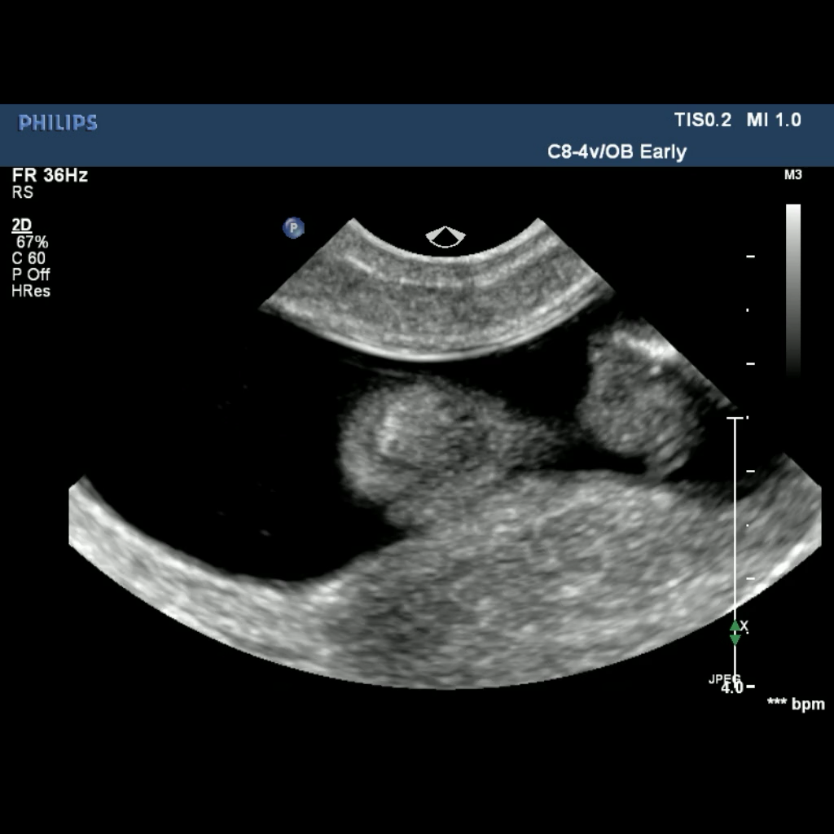
Head

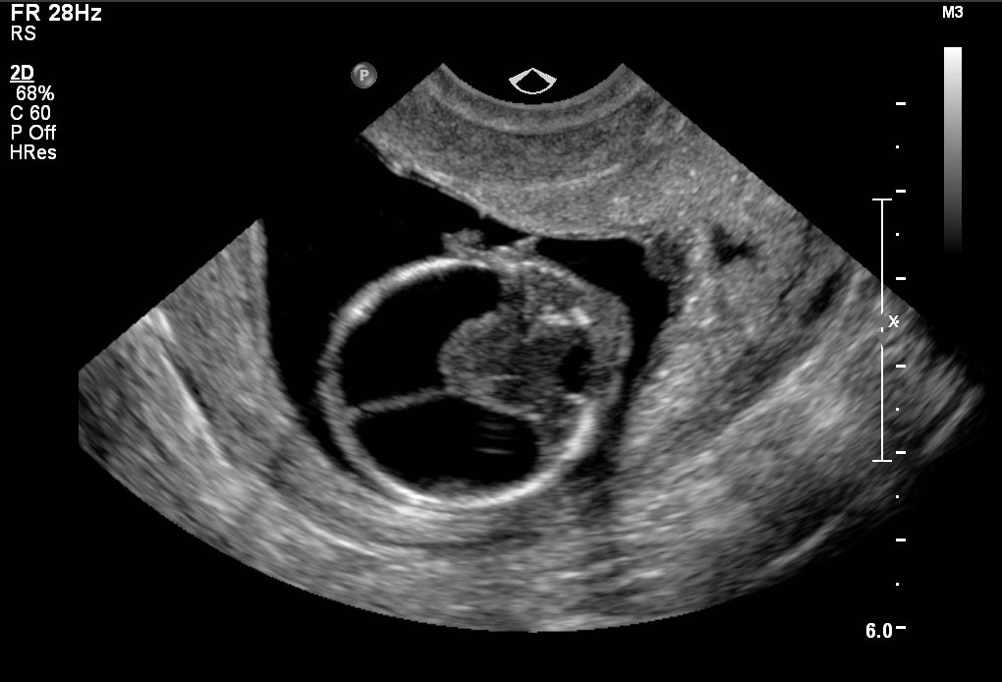
[Provide feedback for the image here]

Kidneys
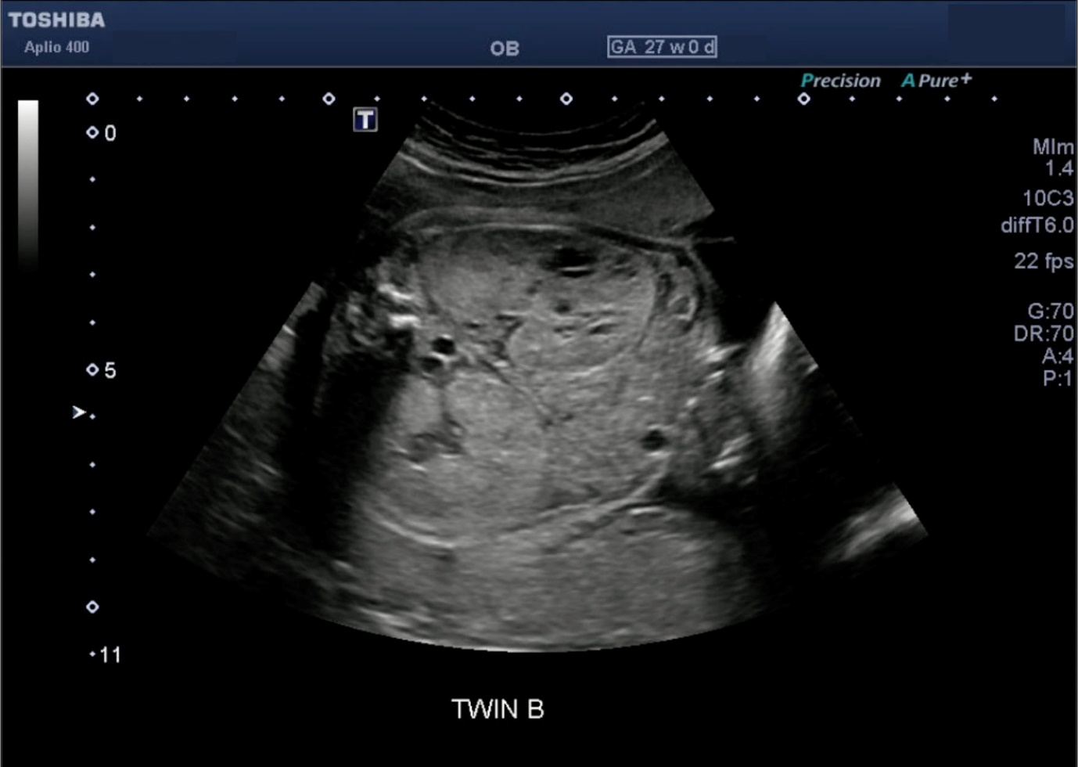
[Provide feedback for the image here]

Extremity - hand
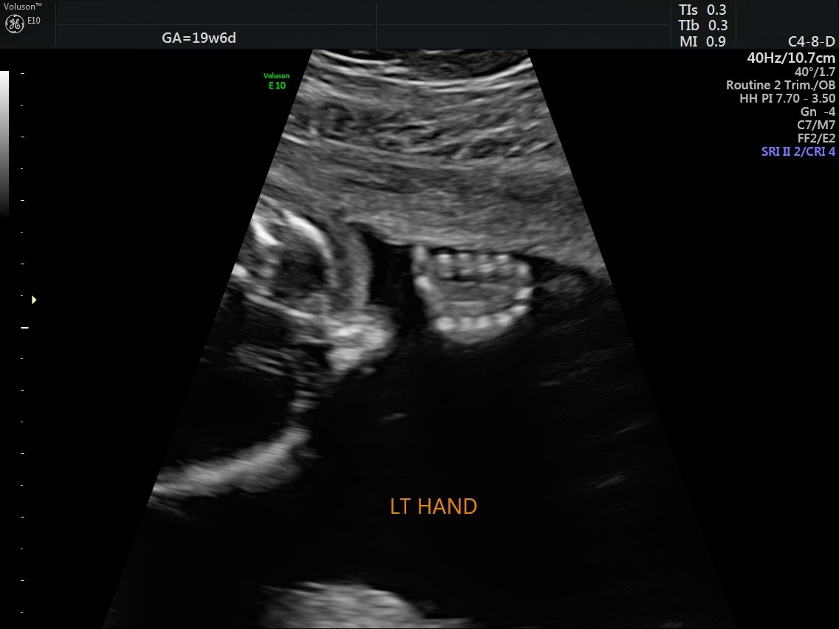
[Provide feedback for the image here]

