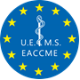EACCME®

European Accreditation Council for Continuing Medical Education

**Certificate**

The ***Third Trimester: an ISUOG Guideline course, building on best practice***

***London, United Kingdom, 03/08/2025 - 03/08/2025***

organized by ***International Society of Ultrasound in Obstetrics and Gynecology***

has been accredited

by the European Accreditation Council for Continuing Medical Education (EACCME®)

for a maximum of ***6.5*** European CME credits (ECMEC®s).

Dr …………………….

has been awarded **[xx]** European CME Credits (ECMEC®s)

for his/her attendance at this event.

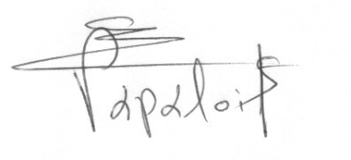

Prof. Vassilios Papalois

*President of UEMS*



Dr João Grenho

*Secretary General of UEMS*

**Accreditation Statement**

Each medical specialist should claim only those credits that he/she actually spent in the educational activity.

Through an agreement between the European Union of Medical Specialists and the American Medical Association, physicians may convert EACCME® credits to an equivalent number of AMA PRA Category 1 Credits™. Information on the process to convert EACCME® credits to AMA credits can be found at <https://edhub.ama-assn.org/pages/applications>.

Live educational activities occurring outside of Canada, recognised by the UEMS-EACCME® for ECMEC® credits are deemed to be Accredited Group Learning Activities (Section 1) as defined by the Maintenance of Certification Program of the Royal College of Physicians and Surgeons of Canada.

**Information regarding the conversion of EACCME® credits**

Credit will be converted based on one (1) hour of participation equalling one credit for all activities. Physicians wishing to convert EACCME® credits to *AMA PRA Category 1 Credit™* will be required to access the AMA website at <https://edhub.ama-assn.org/pages/applications> to obtain the necessary paperwork and instructions. Physicians and other health care professionals will be required to pay a processing fee to the AMA.

For other countries, please contact the relevant national/regional accreditation authority.