**Image Critique Assessment – Month 7**

In the *‘Obstetric and gynaecologic ultrasound curriculum and competency assessment in residency training programs: consensus report’* (attached on the Phase II webpage) the following image criteria are listed as the level 2 competencies:

A. Cervical length (transvaginal ultrasound)

B. Cervical length (transabdominal ultrasound)

C. Endometrial thickness

D. Uterine measurements

E. Ovarian measurements

F. Transvaginal pelvic examination: uterus

G. Transvaginal pelvic examination: ovaries

*The following assessment provides images from this level of competency for you to assess. Please provide feedback for each image in the box provide underneath the image. This feedback will be assessed by your virtual mentor who will support you in improving your image critiquing.*

**Cervical length (transvaginal ultrasound)**

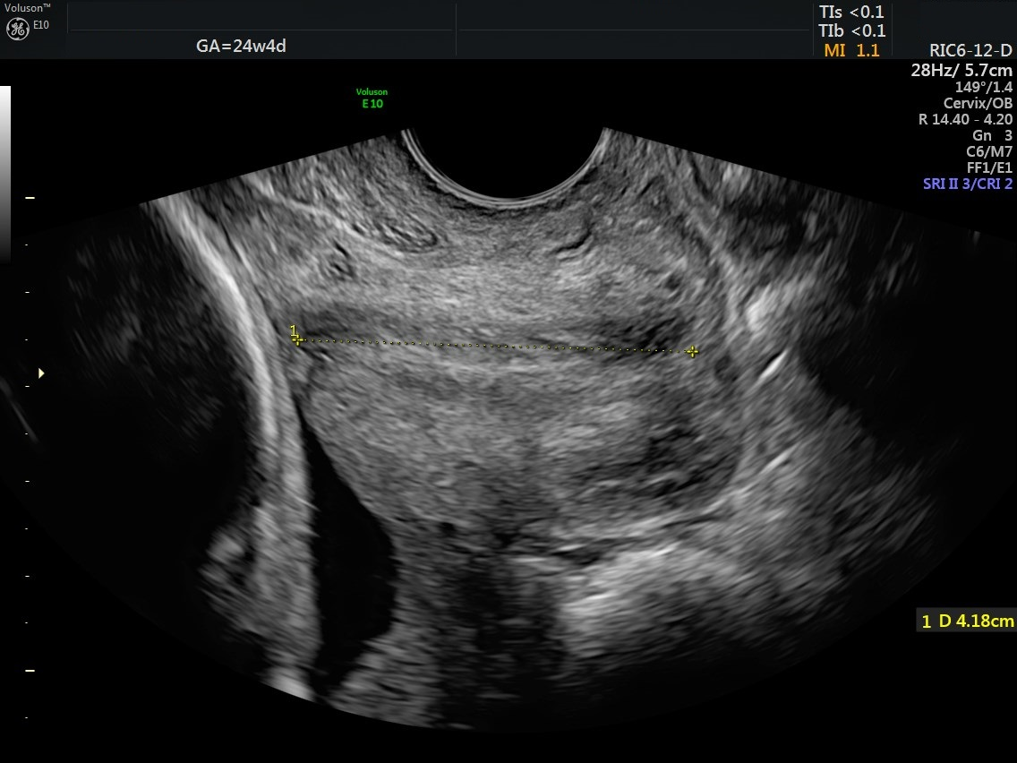

*[Provide feedback for the image here]*

**Endometrial thickness**

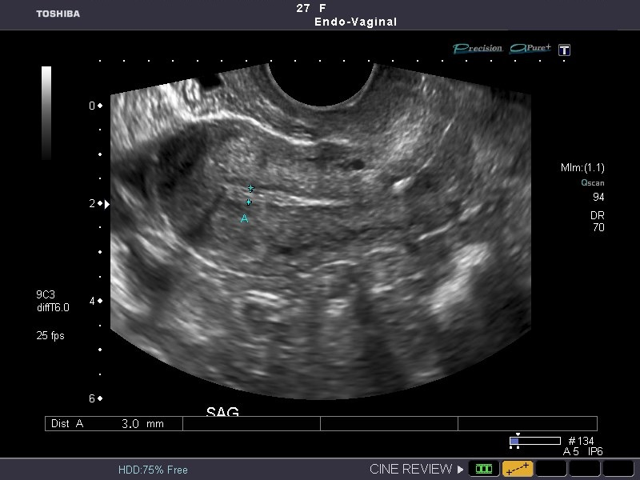

*[Provide feedback for the image here]*

**Uterine measurements**

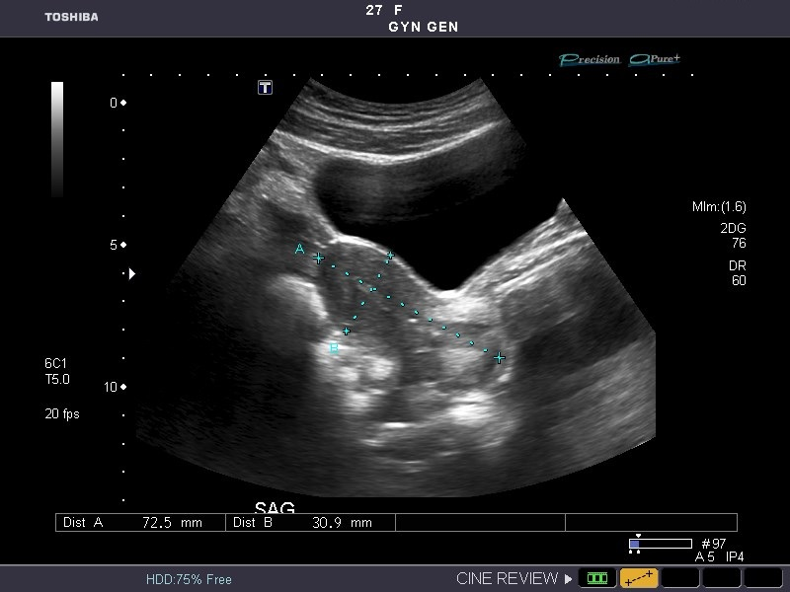

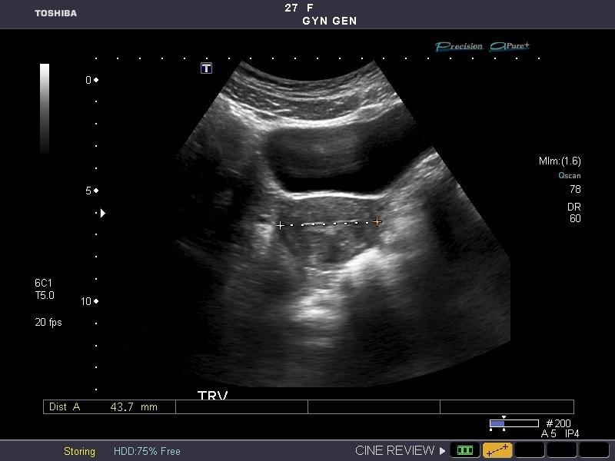

*[Provide feedback for the image here]*